

|  |  |
| --- | --- |
| Smart Leg Physical Therapy  Using SensorTile  Project Proposal |  |
| Physical therapy may be underestimated due to several reasons with catastrophic consequences to patients. This project brings *Intelligent Help* available 24/7 for faster and friendly recovery.  By Alvaro Ramírez, Harvard Extension School, December 2021 |  |

|  |  |  |  |
| --- | --- | --- | --- |
| Motivation Alvaro’s best friend is brilliant ex-NASA physicist, successful entrepreneur and, in his youth, a renowned Peruvian rock star that, due to a recent brain surgery to extract a cancerous tumor, is now on a wheelchair with the right side of his body paralized. Even though he is very intelligent, the lack of movility pushed him to a deep depression. His condition requires a lot of physical therapy but having a therapist all those hours at home is costly and logistically complex. This is where a better solution is needed to complete the work of the physical therapist, something like a friendly system that tells him if the exercise is done correctly or not and that do not complain if the same exercise must be repeated dozens of times, or at any time day or night. Project Classification This project fits into the following categories:   * Wearable Inertial Sensor Application * Physical activity Monitoring * Monitoring of Physical and Physiological Changes in Daily Life * Data visualization and data analysis * Real time data visualization (future implementation) * Gesture recognition * Human Activity Recognition * Pose estimation and recognition * Physical rehabilitation * Artificial Intelligence Application * General event detection application | | |  |
|  | *This project’s goal is to improve life quality by giving back physical mobility***”** |  |  |
| Description The project explores how wearable technology can transform the rehabilitation of people with physical disabilities by providing feedback that could help improve the effectiveness of therapy and improve recovery time.  Physical therapy is a common treatment for individuals with various physical disabilities and injuries. It can improve muscle strength and mobility, decrease pain levels, relieve stress on joints and tissues in the body, restore independence and improve quality of life. A typical physical therapy session includes a range of activities that target the damaged or impaired muscles and joints. The physical therapist specifies a set of activities to engage in during each therapy session and coaches on the proper form or posture required. Use Case The use case for this project is based on a patient that fully or partially lost the mobility of a leg. SensorTile wearable device is used to take advantage of its accelerometer, magnetometer, and gyroscope. With these sensors, the system measures movements and changes in posture while storing data captured and providing feedback.  To obtain the bending angle, the system uses a SensorTile attached to the patient’s ankle as shown in the picture:    Figure 1 | | |  |
| The SensorTile must be located at the end of the limb to obtain the maximum change in position. | | |  |
| Objectives The objectives of the project are oriented to the physical and mental health of the patient. These are the main objectives:   1. Improve the effectiveness of physical therapy process 2. Enable physical therapy to be properly and safely performed without physical therapist presence 3. Cost effective solution  Equipment Required The equipment used for development is:   * SensorTile Development Kit STEVAL-STLKT01V1 * STM32 Nucleo-64 Development Board NUCLEO-F303RE * Personal computer with STM32CubeIDE installed * USB-C 3.1 10-Port Hub with Power Adapter - 36W Powered (12V/3A) * USB 2.0 A-Male to Micro-B Cable * USB 2.0 A-Male to Mini-B Cable * Laptop computer  Proof of Concept or Minimum Value Product The system shall be able to recognize the position of the three sensors, determine the angle, compare it with the goal and provide feedback to the patient. To determine of the goal was reached, the system shall use artificial intelligence to define if the value obtained is within an acceptable range for that specific patient. Final Project deliverable The solution will include a package with the following components:   * Three SensorTiles programmed to obtain the data described in XXX * A Raspberry Pi that controls the sensors (it would be great if we could replace this with the phone) * The software described in XXX to process the data * The software described in XXX to interact with the user  Workplan  |  |  |  | | --- | --- | --- | | Week | End Date | Goal | | 1 | October 12 | * Additional hardware required ordered * Software required identified * Project proposal ready | | 2 | October 19 | * Data collecting software for one sensor developed * Data collecting software for one sensor tested * User interface software designed * Physical implementation designed | | 3 | October 26 | * User interface software development started * Raspberry setup to control three sensors completed * Statistics to be applied defined | | 4 | November 2 | * Tests with three sensors started * Initial data collection started * Statistics preliminary analyses performed | | 5 | November 9 | * Training and testing data for machine learning model collected * Machine learning model developed * Machine learning model tested * Statistics adjusted | | 6 | November 16 | * Machine learning model trained * Machine learning model deployed * User interface software development completed | | 7 | November 23 | * Integration testing * Final adjustments to statistics implemented * Final adjustments to machine learning model implemented * Final adjustments to user interface software implemented * Final adjustments to physical implementation implemented | | 8 | December 7 | * Presentation development * Presentation ready | | | |  |



|  |  |
| --- | --- |
| Technical Description | |
| Lorem ipsum dolor sit amet, consectetur adipiscing elit. Etiam aliquet eu mi quis lacinia. Ut fermentum a magna ut eleifend. |  |

|  |  |
| --- | --- |
| Section Title Describe sensors used  Describe how sensors are used  Describe data obtained  Describe how data is transformed  Describe what is done with data  Describe user interface  Describe feedback to patient   * Lorem ipsum dolor sit amet, consectetur adipiscing elit. Etiam aliquet eu mi quis lacinia. Ut fermentum a magna ut eleifend. Integer convallis suscipit ante eu varius. Morbi a purus dolor. Suspendisse sit amet ipsum finibus justo viverra blandit. * Ut congue quis tortor eget sodales. Nulla a erat eget nunc hendrerit ultrices eu nec nulla. Donec viverra leo aliquet, auctor quam id, convallis orci. Sed in molestie est. * Lorem ipsum dolor sit amet, consectetur adipiscing elit. Etiam aliquet eu mi quis lacinia. Ut fermentum a magna ut eleifend. Integer convallis suscipit ante eu varius.   Lorem ipsum dolor sit amet, consectetur adipiscing elit. Etiam aliquet eu mi quis lacinia. Ut fermentum a magna ut eleifend. Integer convallis suscipit ante eu varius.  Donec sed malesuada orci. Vestibulum faucibus nulla eu est venenatis egestas. Mauris congue dolor et dolor commodo gravida. Fusce eu suscipit lacus, id egestas nisi. Section Title Lorem ipsum dolor sit amet, consectetur adipiscing elit. Etiam aliquet eu mi quis lacinia. Ut fermentum a magna ut eleifend. Integer convallis suscipit ante eu varius. |  |
| Lorem ipsum suas dolor sit amet, cu option vim possim aperiri. |
|  |

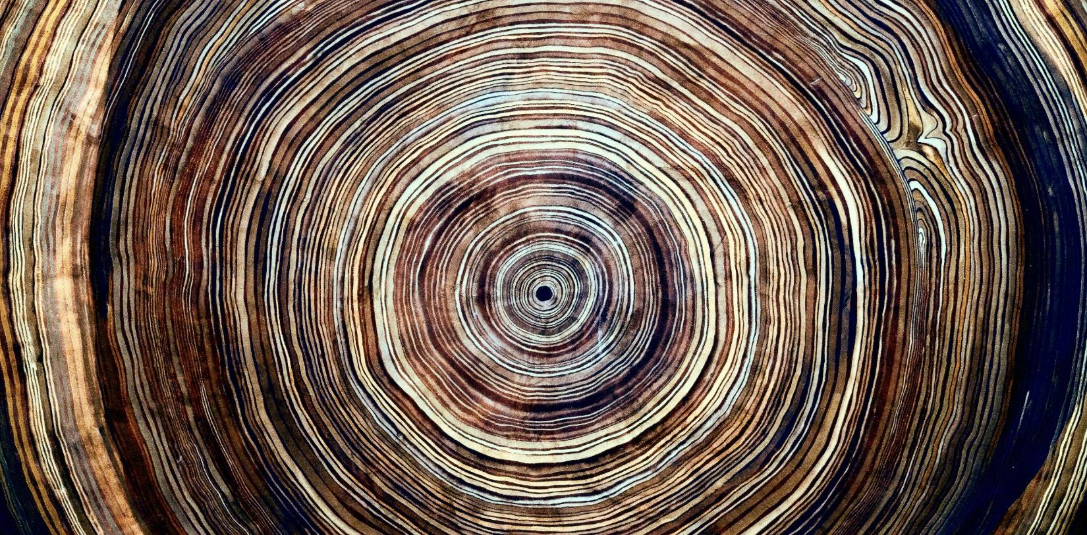

|  |  |  |
| --- | --- | --- |
|  |  |  |
|  | Lorem ipsum dolor sit amet, consectetur adipiscing elit. Etiam aliquet eu mi quis lacinia. |  |
|  |  |  |

|  |  |
| --- | --- |
|  | Section Title Lorem ipsum dolor sit amet, consectetur adipiscing elit. Etiam aliquet eu mi quis lacinia. Ut fermentum a magna ut eleifend. Integer convallis suscipit ante eu varius. Morbi a purus dolor. Suspendisse sit amet ipsum finibus justo viverra blandit. Ut congue quis tortor eget sodales. Nulla a erat eget nunc hendrerit ultrices eu nec nulla. Donec viverra leo aliquet, auctor quam id, convallis orci. Sed in molestie est.  Donec sed malesuada orci. Vestibulum faucibus nulla eu est venenatis egestas. Mauris congue dolor et dolor commodo gravida.  Fusce eu suscipit lacus, id egestas nisi. Ut nec dapibus sapien, id cursus risus. Nullam porttitor, mauris sit amet laoreet ultricies, nulla nibh iaculis tortor, eu congue nisi justo in lorem.  Pellentesque vel congue ante. Suspendisse pretium sem est, a tincidunt nunc dictum a. In mattis arcu dui, non pretium risus convallis quis. Morbi ornare condimentum pharetra.  Vestibulum vitae posuere risus, at viverra metus. Quisque congue, ligula at vulputate blandit, urna ante cursus ligula, bibendum blandit velit nunc nec felis.  Lorem ipsum dolor sit amet, consectetur adipiscing elit. Etiam aliquet eu mi quis lacinia. Ut fermentum a magna ut eleifend. Integer convallis suscipit ante eu varius. Morbi a purus dolor. Suspendisse sit amet ipsum finibus justo viverra blandit. Ut congue quis tortor eget sodales. Nulla a erat eget nunc hendrerit ultrices eu nec nulla. Donec viverra leo aliquet, auctor quam id, convallis orci. Sed in molestie est.  Lorem ipsum dolor sit amet, consectetur adipiscing elit. Etiam aliquet eu mi quis lacinia. Ut fermentum a magna ut eleifend. Integer convallis suscipit ante eu varius.  Lorem ipsum dolor sit amet, consectetur adipiscing elit. Etiam aliquet eu mi quis lacinia. Ut fermentum a magna ut eleifend. Integer convallis suscipit ante eu varius.  Donec sed malesuada orci. Vestibulum faucibus nulla eu est venenatis egestas. Mauris congue dolor et dolor commodo gravida. Fusce eu suscipit lacus, id egestas nisi. Ut nec dapibus sapien, id cursus risus. Section Title Lorem ipsum dolor sit amet, consectetur adipiscing elit. Etiam aliquet eu mi quis lacinia. Ut fermentum a magna ut eleifend. Integer convallis suscipit ante eu varius. fdfd |
| Lorem ipsum suas dolor sit amet, cu option tritani ius possim aperiri. |

|  |  |  |
| --- | --- | --- |
| Lorem ipsum dolor sit amet, consectetur adipiscing elit. Etiam aliquet eu mi quis lacinia. Ut fermentum a magna ut eleifend. Integer convallis suscipit ante eu varius. Morbi a purus dolor. Suspendisse sit amet ipsum finibus justo viverra blandit. Ut congue quis tortor eget sodales. Nulla a erat eget nunc hendrerit ultrices eu nec nulla. Donec viverra leo aliquet, auctor quam id, convallis orci. Sed in molestie est.  **Lorem ipsum sit amet, consectetur adipiscing elit. Etiam aliquet eu mi quis lacinia. Ut fermentum a magna ut eleifend.Integer convallis suscipit ante eu varius.Morbi a purus dolor.**  Cras ornare turpis at ligula posuere, sit amet accumsan neque lobortis. Maecenas mattis risus ligula, sed ullamcorper nunc efficitur sed. Praesent venenatis quam tortor, id viverra nunc rutrum a. Maecenas malesuada ultricies sapien sit amet pharetra. Nunc tempus, risus sodales sodales hendrerit, arcu dolor commodo libero, a sollicitudin quam nulla quis lectus. In at porta mauris.  Maecenas quis leo ipsum. Pellentesque blandit libero quis justo auctor, vitae faucibus ligula scelerisque. Nunc pulvinar pulvinar augue dapibus blandit. Cras ac aliquam sapien. Fusce consectetur est sed ultrices tincidunt. Ut eget ex id odio vulputate interdum ac ut nibh. Donec tempus dui quam, non hendrerit lectus convallis sed. | |  |
| Meandering River Flow | Image Caption: Lorem ipsum dolor sit amet, consectetur adipiscing elit. |  |



|  |  |  |
| --- | --- | --- |
|  |  |  |
| Lorem ipsum dolor sit amet, consectetur adipiscing elit. Etiam aliquet eu mi quis lacinia.  Lorem ipsum dolor sit amet, consectetur adipiscing elit. Etiam aliquet eu mi quis lacinia. Ut fermentum a magna ut eleifend. Integer convallis suscipit ante eu varius. Morbi a purus dolor. Suspendisse sit amet ipsum finibus justo viverra blandit. Ut congue quis tortor eget sodales. Nulla a erat eget nunc hendrerit ultrices eu nec nulla. Donec viverra leo aliquet, auctor quam id, convallis orci. Sed in molestie est.  Cras ornare turpis at ligula posuere, sit amet accumsan neque lobortis. Maecenas mattis risus ligula, sed ullamcorper nunc efficitur sed. Praesent venenatis quam tortor, id viverra nunc rutrum a. Maecenas malesuada ultricies sapien sit amet pharetra. Nunc tempus, risus sodales sodales hendrerit, arcu dolor commodo libero, a sollicitudin quam nulla quis lectus. In at porta mauris.  Maecenas quis leo ipsum. Pellentesque blandit libero quis justo auctor, vitae faucibus ligula scelerisque. Nunc pulvinar pulvinar augue dapibus blandit. Cras ac aliquam sapien. Fusce consectetur est sed ultrices tincidunt. Ut eget ex id odio vulputate interdum ac ut nibh. Donec tempus dui quam, non hendrerit lectus convallis sed. |  |  |

|  |  |  |
| --- | --- | --- |
| Image Caption: Lorem ipsum dolor sit amet, consectetur adipiscing elit. | Top view of a plant |  |
|  | *Lorem ipsum dolor sit amet, consectetur adipiscing elit. Etiam aliquet eu mi quis lacinia.*  Lorem ipsum dolor sit amet, consectetur adipiscing elit. Etiam aliquet eu mi quis lacinia. Ut fermentum a magna ut eleifend. Integer convallis suscipit ante eu varius. Morbi a purus dolor. Suspendisse sit amet ipsum finibus justo viverra blandit. Ut congue quis tortor eget sodales. Nulla a erat eget nunc hendrerit ultrices eu nec nulla. Donec viverra leo aliquet, auctor quam id, convallis orci. Sed in molestie est. | |
|  | *Lorem ipsum dolor sit amet, consectetur adipiscing elit. Etiam aliquet eu mi quis lacinia.* |  |